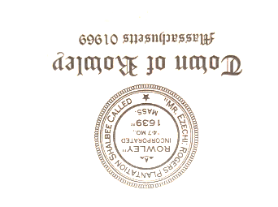

Rowley Council on Aging
Meeting Notice – Meeting Agenda
Wednesday February 21, 2024
10:00 am
Town Hall Annex Conference Room
39 Central Street Rowley, MA

Agenda:

- Call Meeting to Order
- Approval of January Minutes
- Vote on Selectman’s letter
- Financial Report
- Outreach Report
- Director’s Report
- Adjourn

