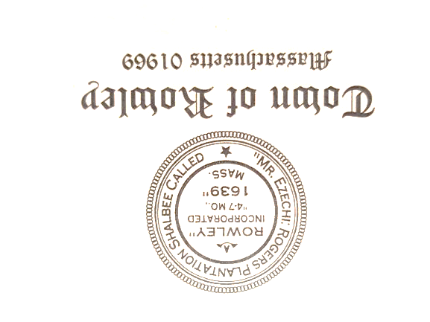
Rowley Council on Aging
Meeting Notice – Meeting Agenda
Wednesday November 15, 2023
10:00 am
Town Hall Annex Conference Room
39 Central Street Rowley, MA

Agenda:

- Call Meeting to Order
- Approval of Oct Minutes
- Director’s Report
- Other Business
- Adjourn

