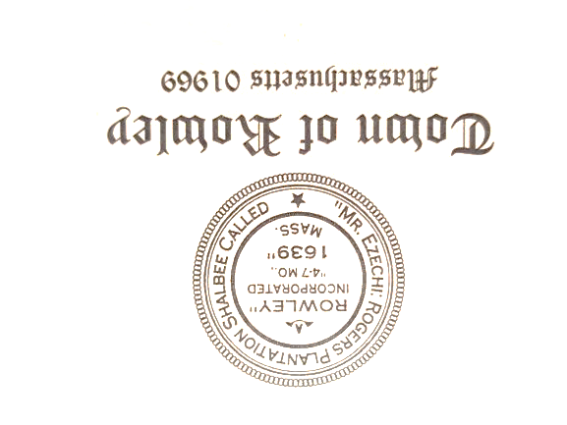
Rowley Council on Aging
Meeting Notice – Meeting Agenda
Wednesday January 17, 2024
10:00 am
Town Hall Annex Conference Room
39 Central Street Rowley, MA

Agenda:

- Call Meeting to Order
- Approval of November Minutes
- Financial Report
- Director’s Report
- Other Business
- Adjourn

